

Cinema booking online system

**Student of the project is :**

**Rosul basher\***

**Fatima abd_alhussain\***

**Hiba abd_alhussain\***

**Zahraa ehsan\***

**Dr. Ayad Hameed Mousa**

**Introduction :**

Nowadays the internet become one of the most important sector in the world, the

internet has changed the way that the people look at life and business, shopping throw the

throw the internet due to the

easy way fined what u looking for with the ability to do it at any time and from anywhere. The

internet booking for cinema online become in the reach of our hand in

home or any other place, the online booking with give us extra details about the company

,other than that, customer suffering will rid of by easy way to save time and save money, the

customer can deal easy with friendly website . no need to go to the company branch and spend

money and time in road and standing in a queue to book tickets, furthermore It will help the

company employees in daily work by make their work more arranged and more connected to

the other company branches.

**-PROBLEM STATEMENT:**

**We wish to make the booking of a cinema as far as one click from our hand, so anyone**

**who want to watching a movie can access to this system throw the internet at**

**anytime and wherever having access to the world web.**

**This system will have a large impact on the cinema by give the ability for reliably**

**update data and the possibility to take action on trigger events and Enhance the time that was**

**take to manage the data as well as the time that was need to retrieve the data, and making the**

**booking more arrange between the branches and more easy to update and book the tickets, by**

**enhance the ability to share the data and reduce the time it takes to share the data. By give a**

**full access to the insert or update data in all the branches in the live time However, the user will have an easy and efficient way of booking without the need to go to the**

**company branch to book his movie and everyone can book his movie from his computer.**

What Cinema Booking Online System ?

**The cinema online allows the customer to book a ticket online**

**If the customer need to book a ticket , the customer should go to the cinema station and**

**buy the ticket a period before the movie time, the company employee will connect with the other**

**branches of the company and see if there is an empty place and write the ticket to him or her**

**and all the process done manually.**

**The project it is help the company to do the booking ticket to the customers in the**

**easier and faster way and also can save the time and money in the operation of booking. This**

**system will allow the customers to do all the operation such as search and booking, and finally know about the special offers.**

**Objective:**

**One of the main objectives identified in this research is to facilitate the process of booking ticket and to know the latest offers and prices, and place and time when it is not accessible to the place directly through the application is loaded in smart devices ,to solve the problem waiting , and to provide the required service to all in a timely manner by the organizing organization , as well as create a website that users can add and control their offer**

SCOPE OF STUDY:

**The scope of this study will cover customer services to how to booking bus ticket by using electronic booking bus system. The system is online website which allows the customer to register before Log in the system, after login the system the customer can search route and date; customer can select the route and book their tickets.**

**The system also decrease the company work ,which allow the staff to control the day by day operation with easy way , manager can manage the system such as add new route ,delete the route, edit it ,make the price for each one , add new bus , delete the bus ,schedule the bus to** **specific route ,and make the time table to the bus .the manger allow to give password with user name to each staff work in this system.**

***List of requirements :***

**Listed below are the functional requirements and non-functional requirement of the system. In the priority column, the following short hands are used:**

***.m_mandatory requirement (something the system must do)***

***.d_ desirable requirement(something the system preferably should do)***

***.o_ option requirement(something the system may do)***

***Functional requirements***

|  |  |  |  |
| --- | --- | --- | --- |
| ***Priorit***  ***y*** | ***Requirement description*** | ***Requirement id*** | ***No.*** |
|  | ***login*** | ***cbos_01*** |  |
| ***m*** | ***User can login in the system to make booking*** | ***cbos_o1_01*** | ***1*** |
| ***m*** | ***Admin can log in to enter the system*** | ***cbos_01_02*** | ***2*** |
|  |  |  |  |
|  | ***registeration*** | ***cbos_02*** | ***4*** |
| ***m*** | ***User must register before login the system*** | ***cbos_02_01*** | ***5*** |
|  | ***must fill all filed in the registerration from otherwise the*** | ***cbos_02_02*** |  |
|  | ***View film*** |  |  |
| ***m*** | ***user can view film after registr*** | ***Cbos_03_01*** | ***6*** |
| ***m*** | ***admin can view film*** | ***Cbos_03_02*** | ***7*** |
|  | ***payment*** |  |  |
|  | ***user must pay to book atiket*** | ***Cbos_04_01*** | ***8*** |
|  | ***admin must see apayment*** | ***Cbos_04_01*** | ***9*** |
|  | ***booking*** |  |  |
| ***m*** | ***user must booking to cancel the booking or to select afilm*** | ***Cbos_05_01*** | ***10*** |
| ***m*** | ***admin must see booking of user to make the tiket*** | ***Cbos_05_01*** | ***11*** |

***Non_functional reequirment :***

|  |  |  |  |
| --- | --- | --- | --- |
|  | **Requirement Description** |  | ***No*** |
|  | **Reliability issues** |  |  |
|  | If the system should crash no more than once per 24 hours |  | ***18*** |
|  | If the system has been crashed, it should not be more than 20 Minutes |  | ***19*** |
|  | If the systems has been crashed, it should behave perfectly normal when reloaded again |  | ***20*** |
|  |  |  |  |
|  | **Usability issues** |  |  |
|  | That means we should make sure that the system stay working smoothly without any interruption |  | ***21*** |
|  |  |  |  |
|  | **Security issues** |  |  |
|  | Only Administrator will be able to enter the system to make maintenance |  | ***22*** |
|  |  |  |  |
|  | **Performance** |  |  |
|  | The system must have a high speed of manipulation data and reply to the user request |  | ***23*** |

Use case diagram:

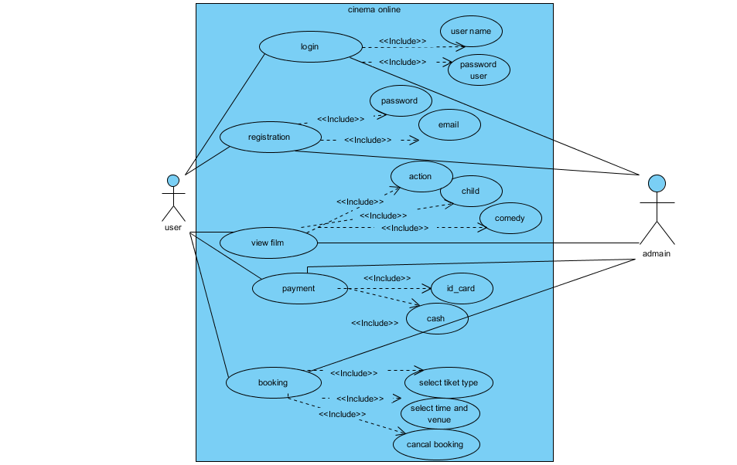

**Use case: login (cobs_01)**



**BRIEF DESCRIPTION (cobs_01_01)**

This use case is initiated by user; this use case will enable the user to login into the system.

**PRE-CONDITIONS (cobs_01_02)**

.The user must registered before login the system (the user has user name and password).

**CHARACTERISTIC OF ACTIVATION (cobs_01_03)**

• Event driven (on user’s choice ).

**FLOW OF EVENTS (cobs_01_04)**

**BASIC FLOW (EBBS_02_02_01)**

This use case begin when the user enter the main page and press (login here) button.

• The system will display login form.

• The user enters the ID and Password and press “login” button. [A-1: Forget ID or Password ]

• The system will retrieve the ID & Password from database.

• The system will verify ID & Password [E-1: wrong ID & Password].

• System will display main page.

**ALTERNATIVE FLOW (cobs_01_02_02)**

 Forget Id & Password  

 Press “forget password “ button.

• The system show password recovery page.

• The user should enter his /her e-mail.

• The user will press “retrieve password “button.

• The system retrieve user E-mail from database.

• The system will verify user E-mail(E-1 :A-1 :E-mail not exist ).

• The system will send ID & Password by e-mail and display retrieve successful page.

**EXCEPTIONAL FLOW (cobs_01_02_03)**

**[ E-1:A-1:E-Mail Not Exist]**

The system will show error message “E-mail not exist “and display the main page.

**POST-CONDITIONS (cobs_01_05)**

.The user Login to the system.

**RULE(S) (cobs_01_06)**

* Not applicable.

**CONSTRAINT(S) (cobs_01_07)**

The user must enter the correct user name and password.

**USE CASE: REGISTERION MEMBER(COBS_02)**



**BREIF DESCRIPTION (cobs_02_01)**

This use case is initiated by the user. This use case will enable the user to register by filling the registration form, if the information is approved by the system; the user will informed that he/she is registered.

**PRE-CONDITIONS (cobs_02_02)**

• Not applicable.

**CHARACTERISTIC OF ACTIVATION (cobs_02_03)**

• Event-driven (on user’s choice).

**FLOW OF EVENTS (cobs_02_04)**

**BASIC FLOW (cobs_02_02_01)**

• The use case begins when the user enter main page and press “ Register “ button.

• The system will display registration form.

• The user will fill registration form with the correct details which include (User ID, Password, Name, E-mail, Contact no. , Address, Identification type, Identification no.).

• User press “submit ‘’button.

• The system will verify registration information with the database [E-1: incorrect information].

• System retrieve ID & E-mail from database.

• Systems will verify ID & E-mail [E-2: New ID already exists].

• System creates a new account.

• System will display main page with successful message.

**ALTERNATIVE FLOW (cobs_02_04_02)**

• Not applicable.

**EXCEPTIONAL FLOW (cobs_02_04_03)**

**[E-1: Incorrect Information]**

• The system will show error message “ please fill all the information fields”

• The system will display the registration page.

**[E-2: already registered]**

• The system will show the following error message “The user already registered”

• The system will display the registration page.

**POST-CONDITIONS (cobs_02_05)**

• The system will update the database.

**RULE(S) (cobs_02_06)**

• Not applicable.

**CONSTRAINT(S) (cobs_02_07)**

• Not applicable

**Use case :view film (cobs_03)**

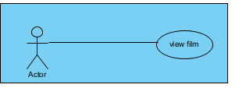

**BREIF DESCRIPTION(cobs_03_01)**

**use case :booking (cbos)**

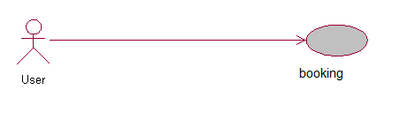

**BRIEF DESCRIPTION(cbos)**

This use case is initiated by the user. This use case will enable the user to booking by select the coach , seat and confirm the booking.

**PRE-CONDITIONS** (**cbos**)

The user must be verified that he/she already login the system.

The user must do search destination.

**CHARACTERISTIC OF ACTIVATION (cbos)**

• Event-driven (on user’s choice).

**BASIC FLOW (cbos)**

The user press “book” button.

• The system will retrieve available seats for the selected route.

• The system will display board of available seats form.

• The user will select his/her seat.

• The user will press “next “button [A-1: Return back].

• The system will book the selected seat for 5 min.

• The system will display payment page.

• The user will select payment method (visa card, master card, etc).

• The user will press “proceed to payment” button.

The system will verify seat availability[ E-1: The seat booked by other or exceed 5 min ] .

• The system will display payment mode page .

• The user will enter credit card details (card number, Expiry date, cvv2).

• The user press “submit” button [A-2: cancel].

• The system will request credit card details from the bank.

• The bank will replay.

• The system will check bank decision about credit info [E-2: credit info. Incorrect].

• The system will ask deduct ticket amount , [1]

• The bank will reply .

• The system will check bank decision about credit balance. [E-3: credit balance insufficient].

• The system will display ticket details page.

ALTERNATIVE FLOW(S) (EBBS_04_04_02)

[**A-1: Return back]**

• The user press “Return back “button.

• The system will display previous page.

[A-2: Cancel]

• The user will press “cancel” button.

• The system will display the main page.

**10.4.3 EXCEPTIONAL FLOW (cbos)**

[**E-1: The Seat Booked By Other or Exceed 5 Min]**

* • The system will show seat booked or exceed time error message and display booking page.

[**E-2: credit info. Incorrect]**

• The system will show incorrect error message and display booking page.

• The system will show insufficient credit error message and display booking page .

**10.5 POST-CONDITIONS (cob)**

**10.6 RULE(S) (EBBS_04_06)**

**10.7 CONSTRAINT(S) (cbos)**

• The system will update the database.

• Not applicable.

• Not applicable.

**Use case :payments(cbos)**

**Activity diagram for login:**

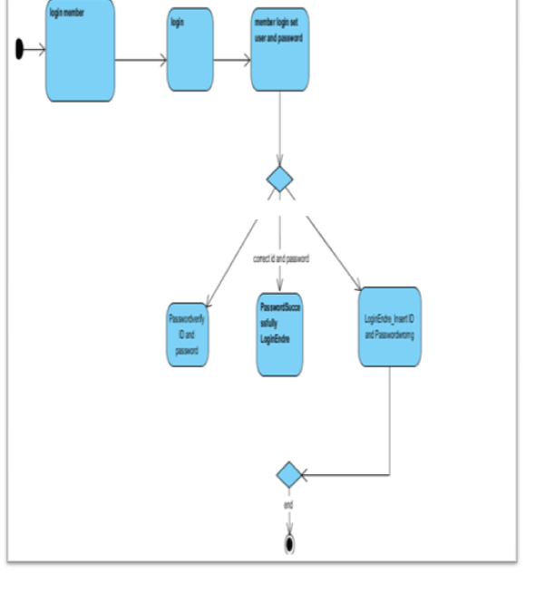

**Activity diagram for Register Member:**

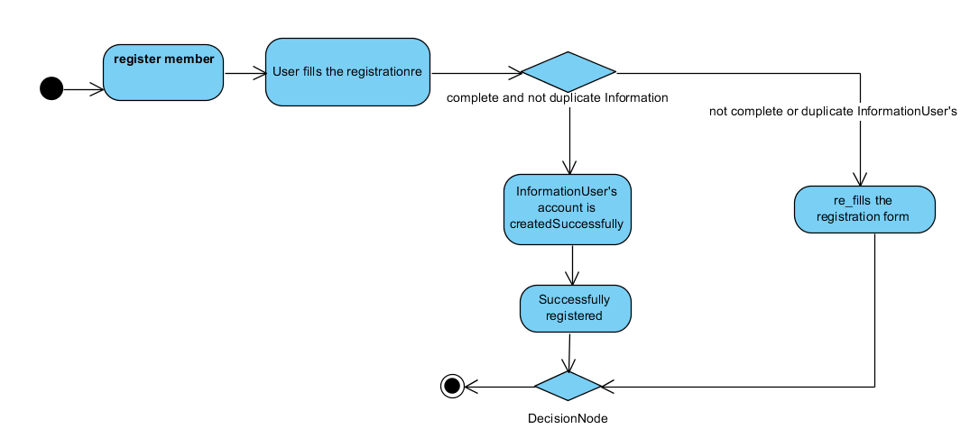

**Activity diagram for view film**

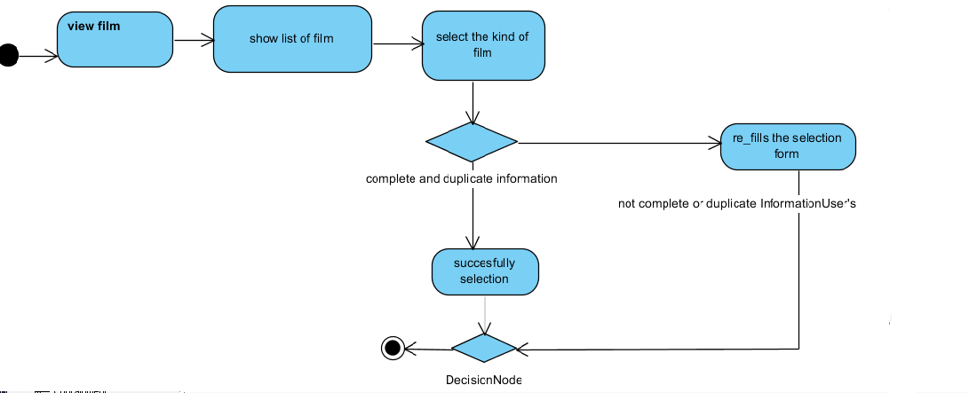

**Activity diagram for booking :**

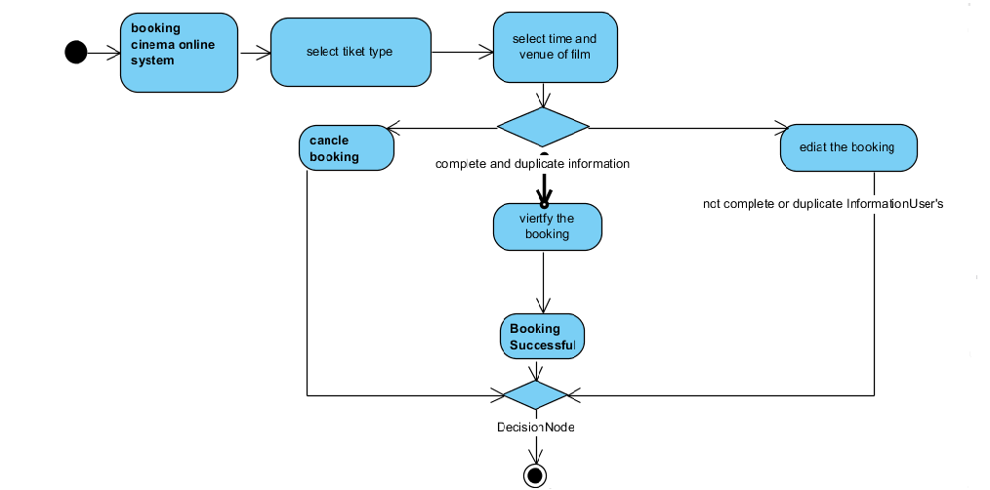

**Activity diagram for payments:**

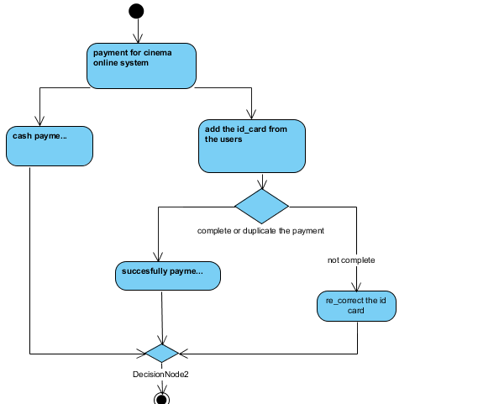

**3_ANALYSIS SEQUENCE DIAGRAM**

**SEQUENCE DIAGRAM FOR USE CASE REGITER MEMBER : BASIC FLOW**

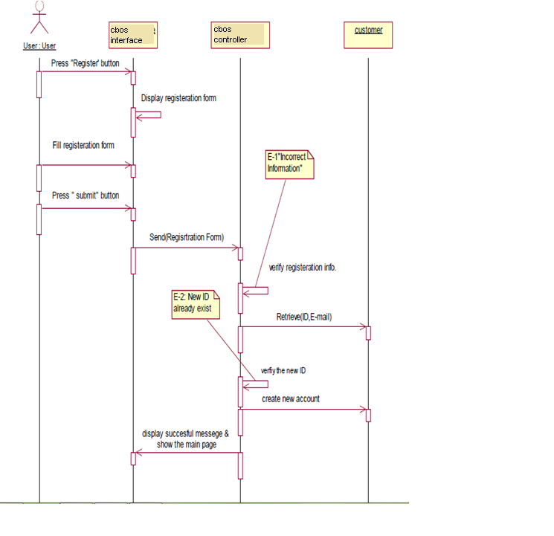

**SEQUENCE DIAGRAM FOR USE CASE REGITER MEMBER: EXCEPTIONAL FLOW E-1**

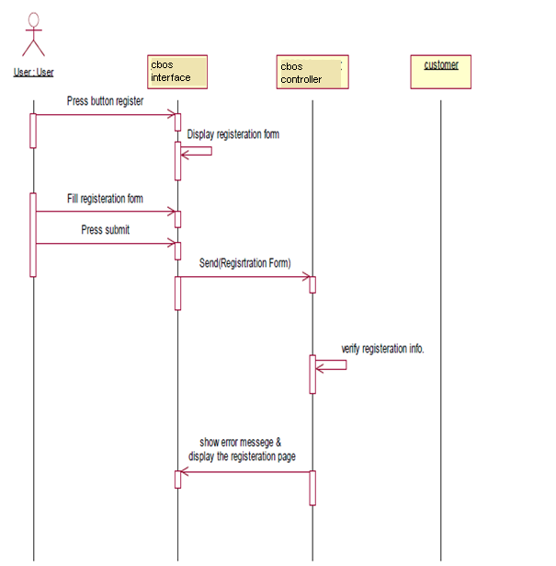

**SEQUENCE DIAGRAM FOR USE CASE REGITER MEMBER: EXCEPTIONAL FLOW E-2**

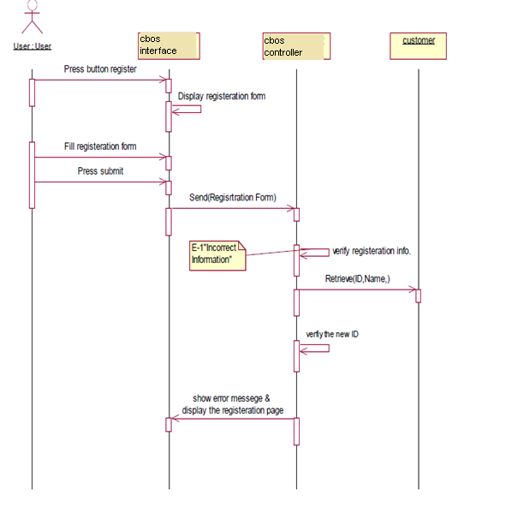

**SEQUENCE DIAGRAM FOR USE CASE LOGIN : BASIC FLOW**

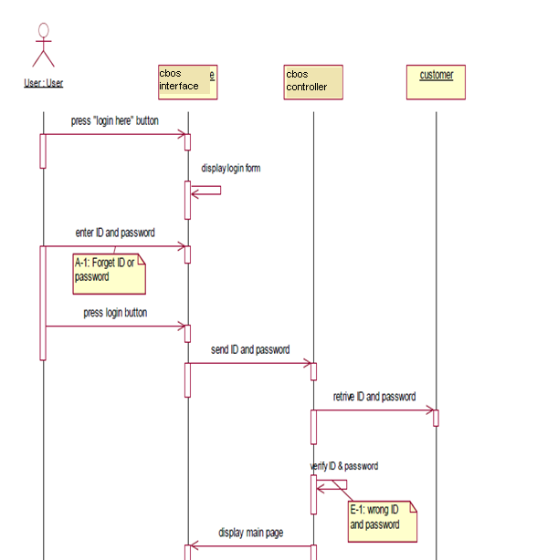

**-SEQUENCE DIAGRAM FOR USE CASE LOGIN : EXCEPTIONAL FLOW E-1**

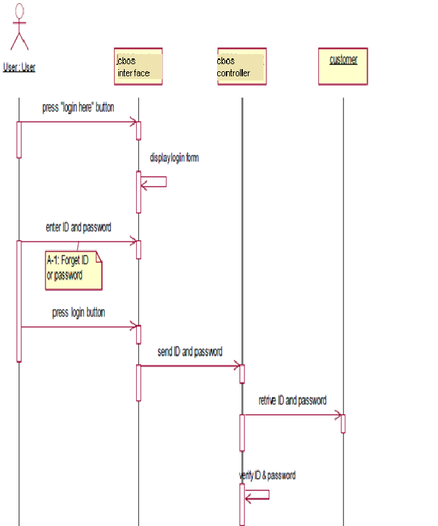

**SEQUENCE DIAGRAM FOR USE CASE LOGIN : ALTERNATIVE FLOW A-1**

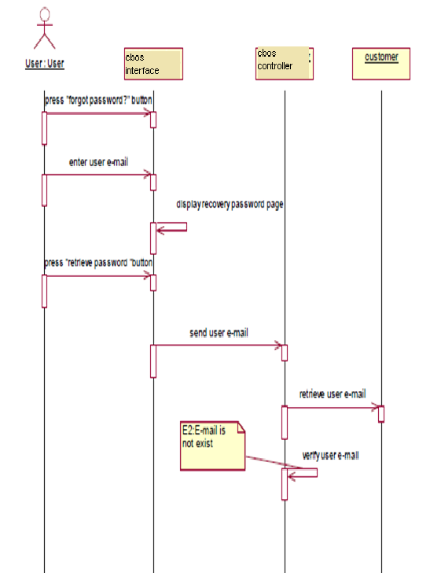

**SEQUENCE DIAGRAM FOR USE CASE LOGIN : EXCEPTIONAL FLOW A-1:E-2**

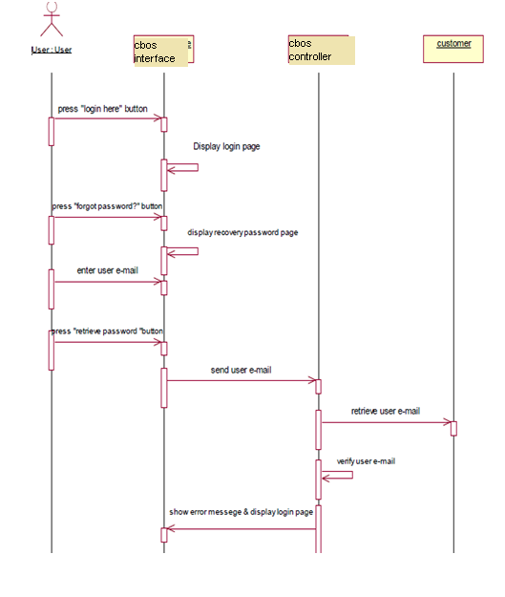

**SEQUENCE DIAGRAM FOR USE CASE view film : BASIC FLOW:**

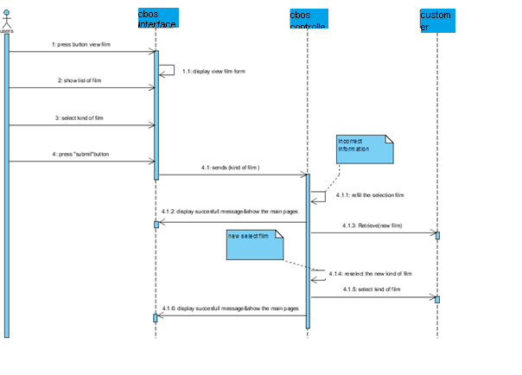

**SEQUENCE DIAGRAM FOR USE CASE view film : EXCEPTIONAL FLOW cbos-1:**

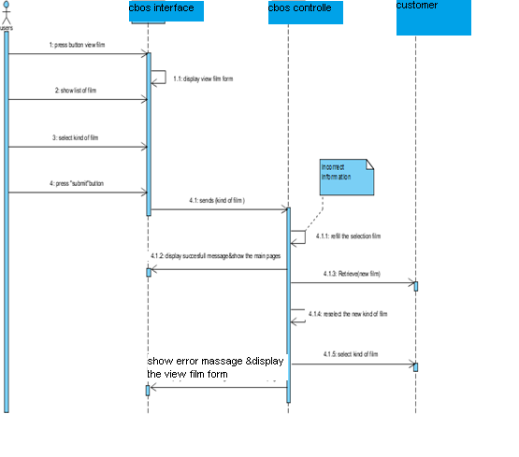

**SEQUENCE DIAGRAM FOR USE CASE view film : EXCEPTIONAL FLOW cbos-2:**

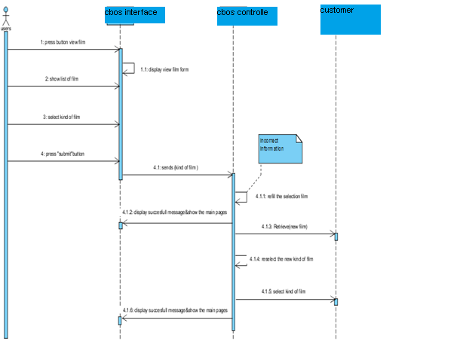

Booking sequence diagram:basic flow

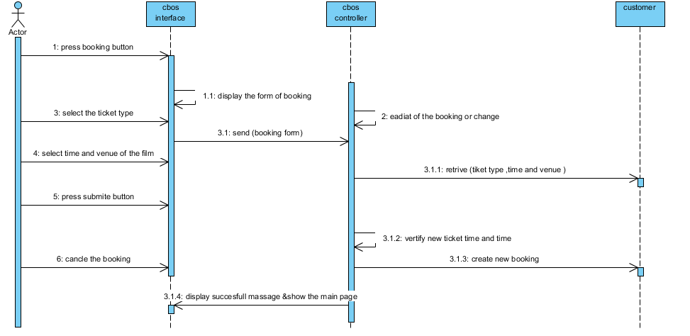

Booking sequence diagram : **EXCEPTIONAL FLOW cbos-1:**

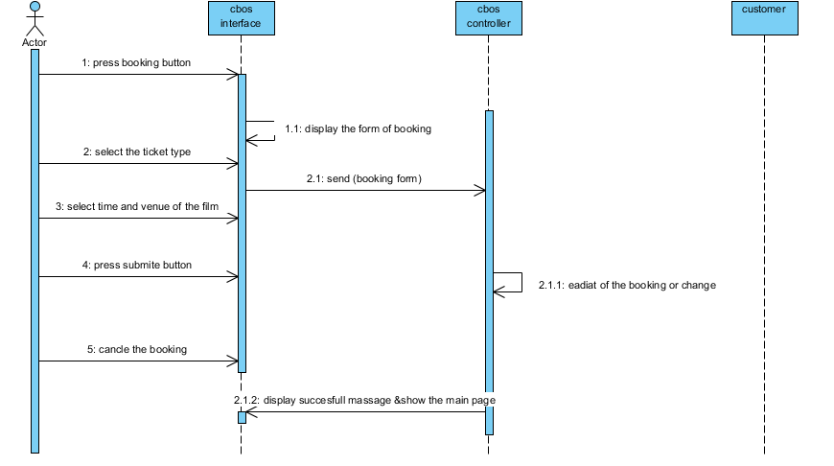

Booking sequence diagram : **EXCEPTIONAL FLOW cbos-2:**

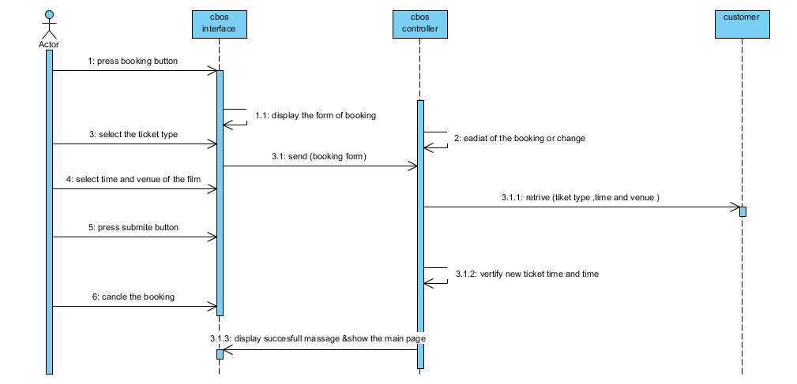

Payment sequence diagram : **basic flow**

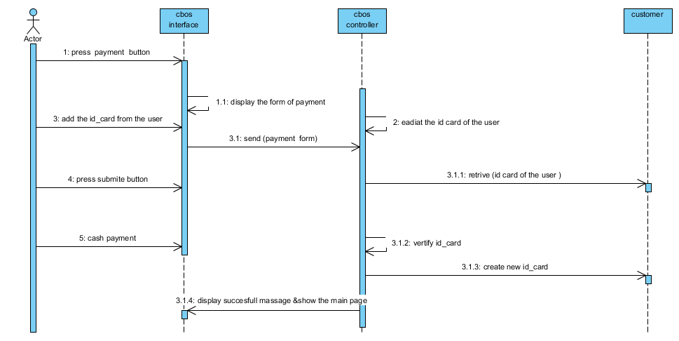

payment sequence diagram : **EXCEPTIONAL FLOW cbos-1:**

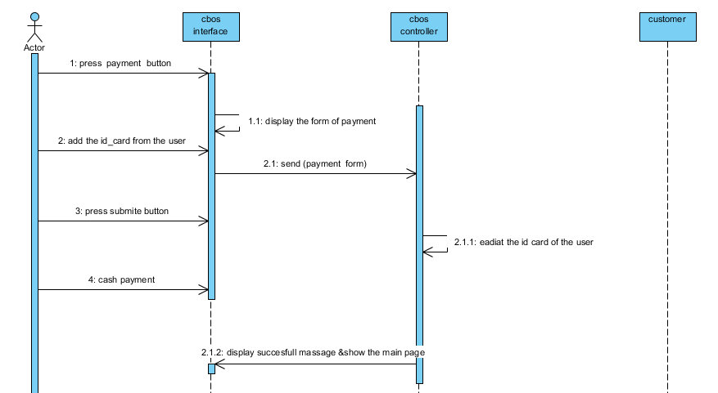

payment sequence diagram : **EXCEPTIONAL FLOW cbos-2:**

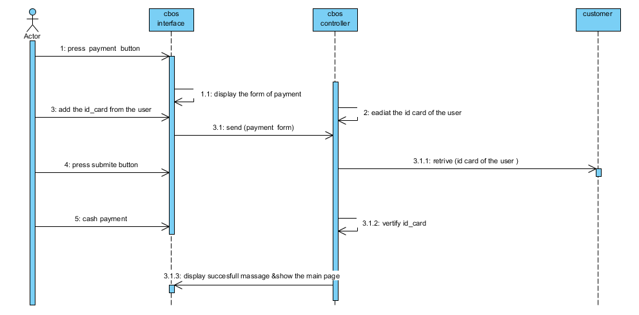

COURSE 2:SOFTWARE TEAM

GANT CHART:

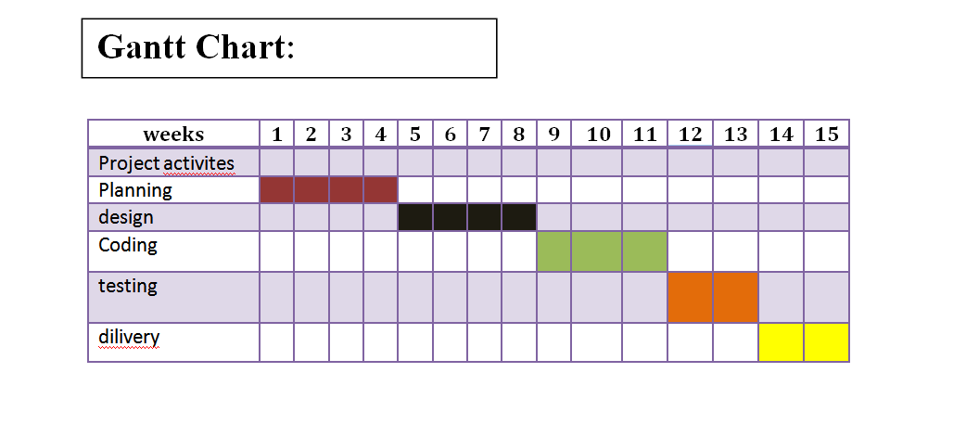

1.